Computer Science Jeroo Lab 4C – Chaos Maze Lab Value - 100

Lab Goal: To analyze a problem and involve branching and decision making in creating a solution for the problem. You must determine how times to hop, when to turn and most importantly when to stop. You must create commands based on the various requirements of this problem.
Lab Description: This lab requires you to use a wide variety of if commands. Each cycle of the loop should produce movement on only 1 conditional at a time. If none of the various conditionals are met, the jeroo should hop twice in the direction it is currently facing. This type of programming involves not only using if but using else also. Failure to use the proper commands will mean your Jeroo is at risk as he may end up in the water or the nets.
.
Files Needed:
Jeroo_Lab4C.jsc
ChaosIsland.jev

Starting Screen:

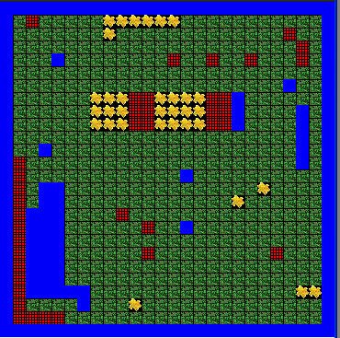
algorithm help

Required Conditionals
- Net Ahead – Turn right and hop twice
- Net Left – Turn Right – hop once
- Net Right – Hop 3 times
- Flower Left – Turn right and hop
- Flower Right – Hop
- Water Left – Hop twice
- Water Right – Turn left – hop twice
- Water Ahead – turn right – hop 4 times

Postcondition –
- Successful hop through the nets
- Jeroo is not in the nets
- Jeroo is facing East
- Jeroo is facing the flower.

Ending Screen:
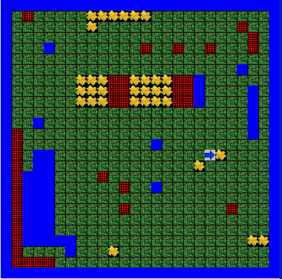

BONUS: Write the loop and ifs as part of a method to solve the maze. +10

